British Library Event Launches Joseph Rufino Cordeiro Foundation
-TOP NEWSCULTUREUK NEWSDECEMBER 21, 2021
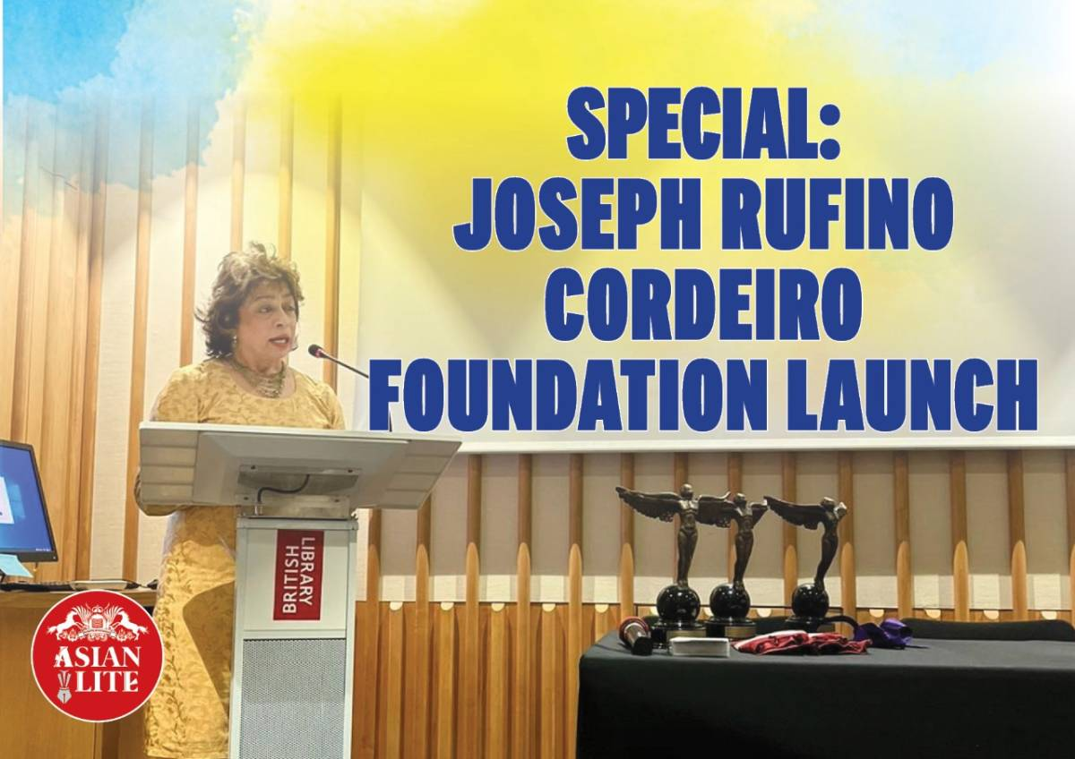

The Joseph Rufino Cordeiro Foundation was founded with the goal of supporting national and international projects that promote science, the arts, and sports, as well as the cultural ties between the UK and India … reports Asian Lite News
The Joseph Rufino Cordeiro Foundation was formally launched in the UK with an intimate gathering at the British Library. Invited by Mary Anne Cordeiro, co-founder and chair of the foundation, friends and well-wishers gathered in the Bronte Room to learn about the foundation’s current projects and future goals, with a special introductory speech from Minister (Coord) for the Indian High Commission, Manmeet Singh Narang.
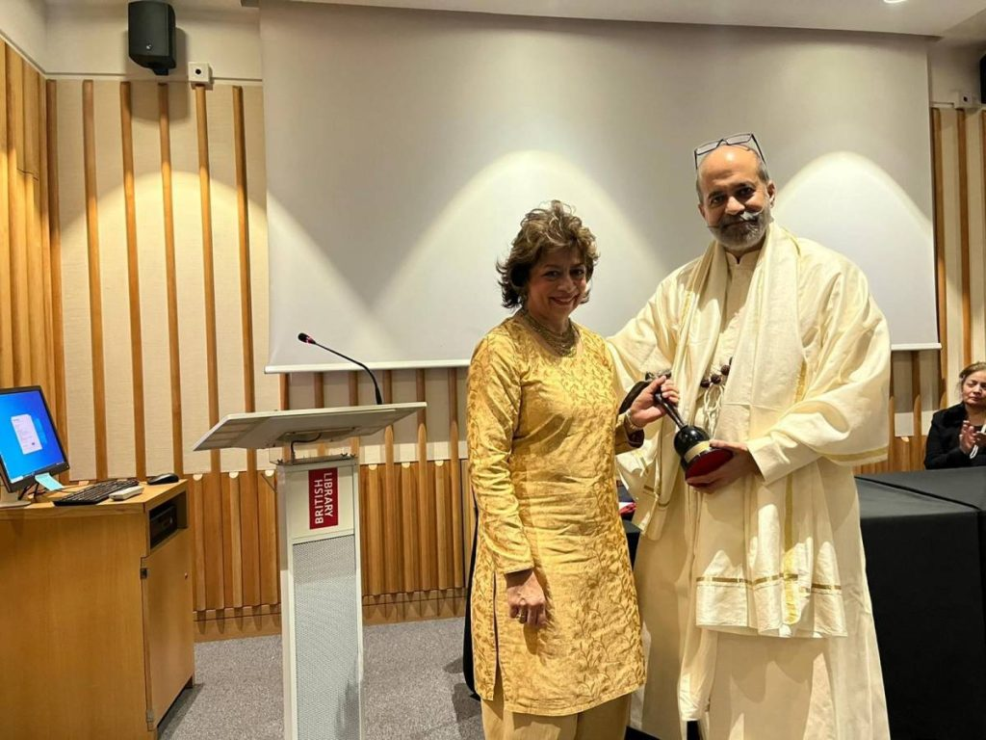British Museum Event Launches Joseph Rufino Cordeiro Foundation

The Joseph Rufino Cordeiro Foundation was founded with the goal of supporting national and international projects that promote science, the arts, and sports, as well as the cultural ties between the UK and India.
Founded by the father-daughter team of Joseph Rufino Cordeiro – who sadly passed earlier this year – and Mary Anne Cordeiro, the foundation has already been working in India to encourage these three pillars of society with projects like their ambitious Bible translation project. In collaboration with Banares Hindu University, Sanskrit scholars are working to translate one of the longest, most comprehensive Bibles into the world’s oldest language to make its spiritual knowledge accessible to a whole new audience.
The event also served as the first awards ceremony for the JRCF Award for Excellence, honouring those who have achieved outstanding things in the fields of Art, Science, and Sport. Honourees included Professor Hagan Bayley of Oxford University for Science, Shree Udayraj A Gadnis for Art, and Tessa Sanderson CBE for Sports.
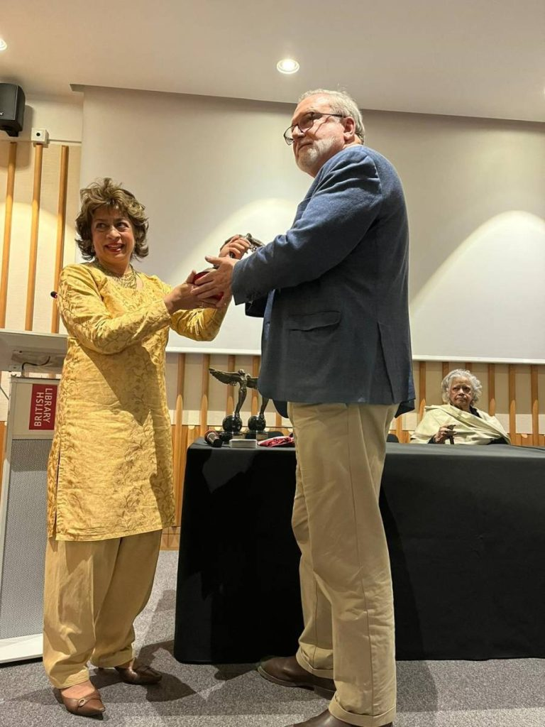British Museum Event Launches Joseph Rufino Cordeiro Foundation

Bayley, whose work in DNA sequencing has been a great help in developing COVID treatments, said he was honoured to receive the award.
“This is a very special award,” he said, “almost intimate, coming from such a small and new foundation. Mary Anne has put so much thought and care into the work she is doing.”
Mary Anne Cordeiro herself said it was ‘like a miracle’ to be able to officially launch the foundation in person. “We’re excited to continue nurturing emerging talent,” she said. “We’re in the process of formulating the best way to train and support healthcare workers to deliver much needed healthcare services in local Goan communities right now, and our work is only just beginning.”
This insight into the current projects and future ambitions of a small and emerging charitable foundation promises great things to come. Now the foundation has been officially launched in the UK, the work of the Joseph Rufino Cordeiro Foundation will be able to advance in so many different directions.
- British Museum Event Launches Joseph Rufino Cordeiro Foundation
- British Museum Event Launches Joseph Rufino Cordeiro Foundation
- 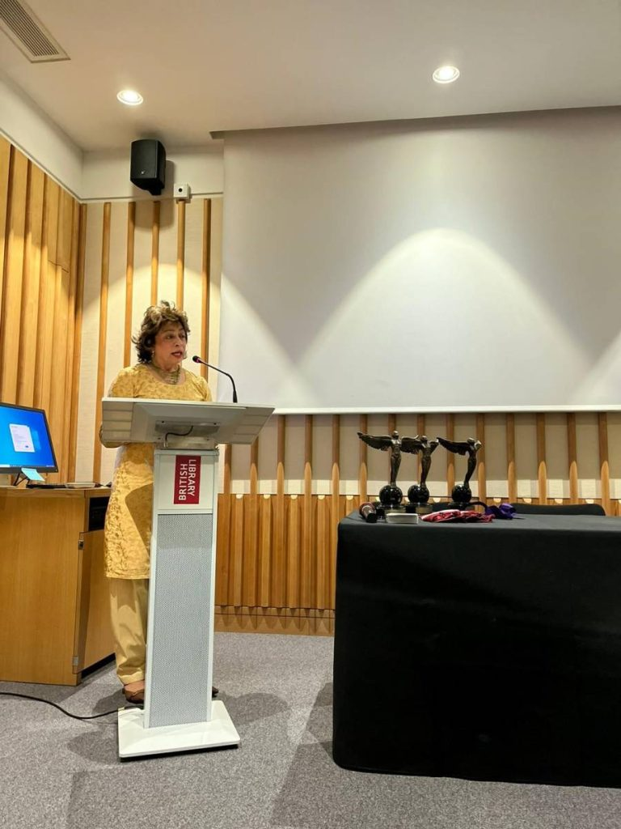British Museum Event Launches Joseph Rufino Cordeiro Foundation
- 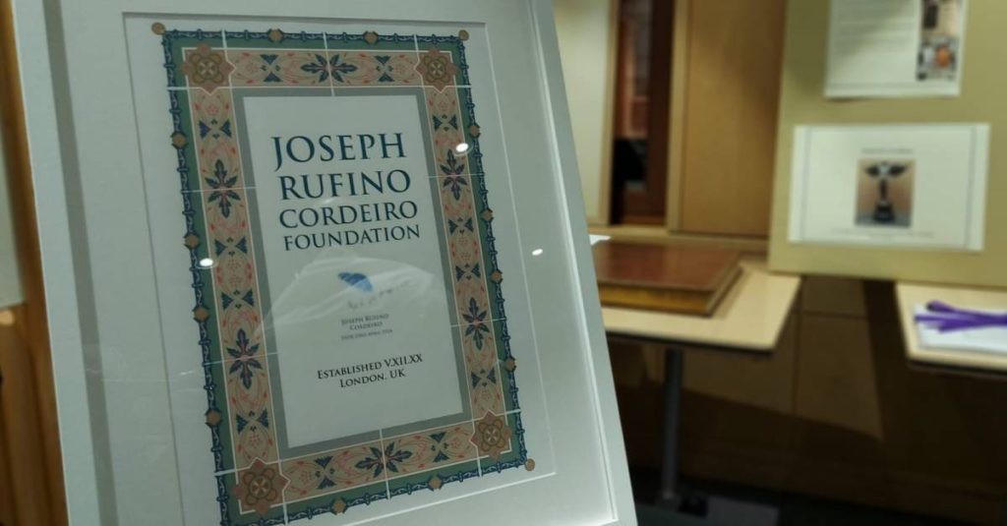British Museum Event Launches Joseph Rufino Cordeiro Foundation
- 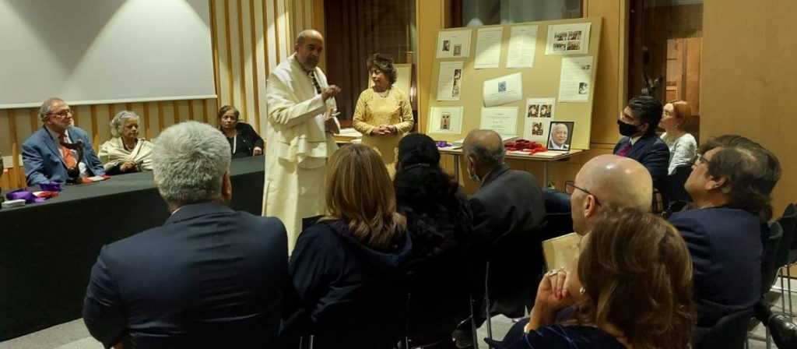British Museum Event Launches Joseph Rufino Cordeiro Foundation
- 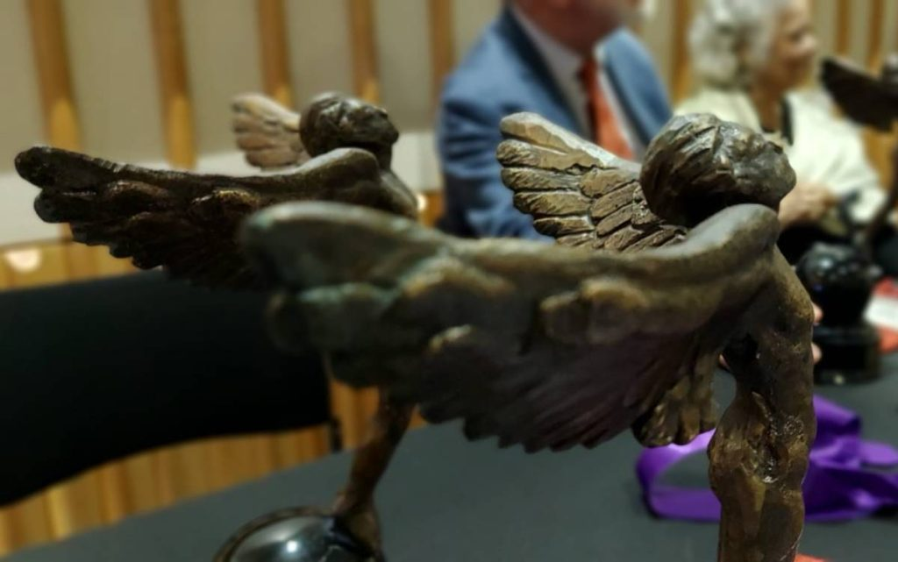Awards – British Museum Event Launches Joseph Rufino Cordeiro Foundation –
- 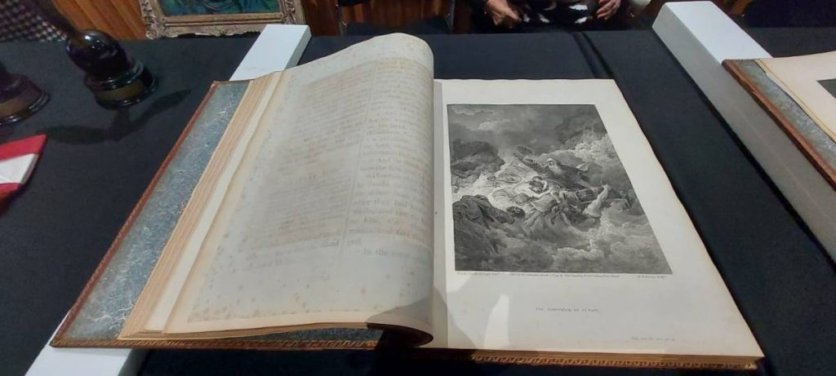
BY NEWSDESK

